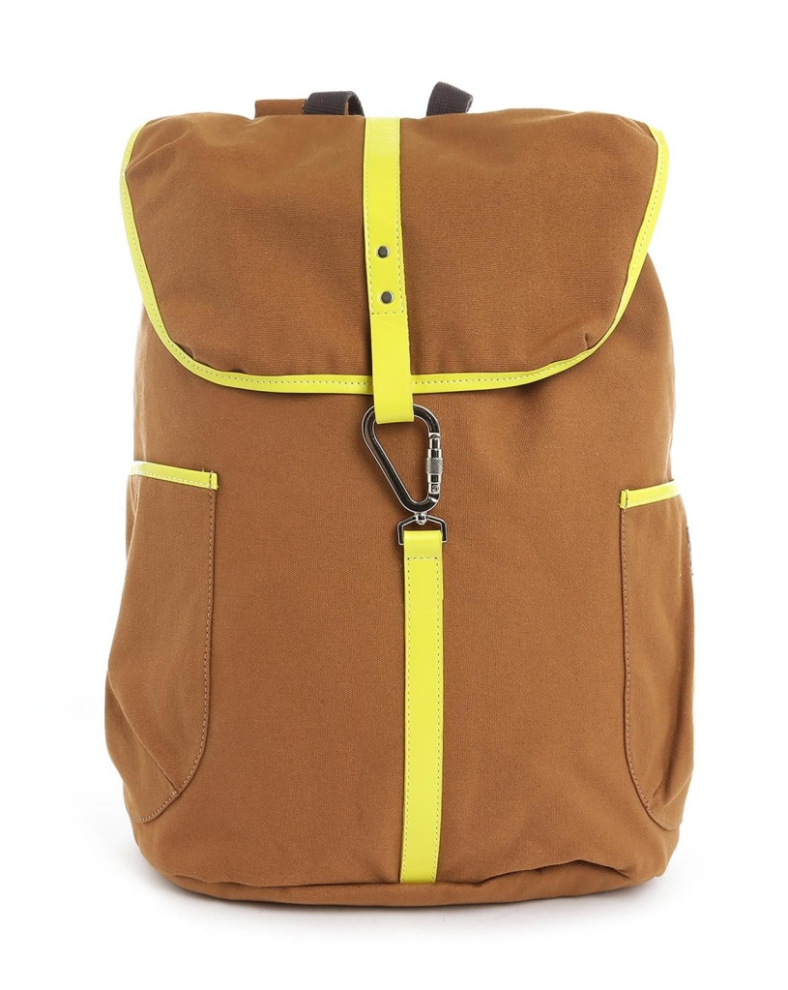

# CAMEL MOUNTAIN MATTE BROWN -010

|  |  |
| --- | --- |
| BRAND | CAMEL MOUNTAIN |
| ITEM DIMENSION | 2 x 4 x 12.13inches |
| MODEL NAME | 010 |
| COLOR | MATTE BROWN |
| PRICE | **RS 1450** |